**2 Pointers Pattern Understanding –**

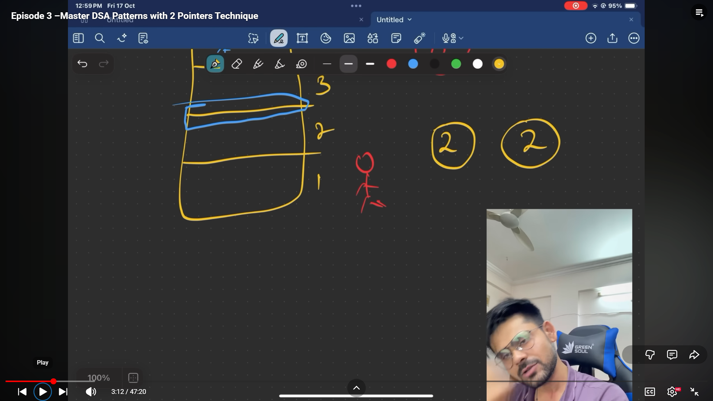

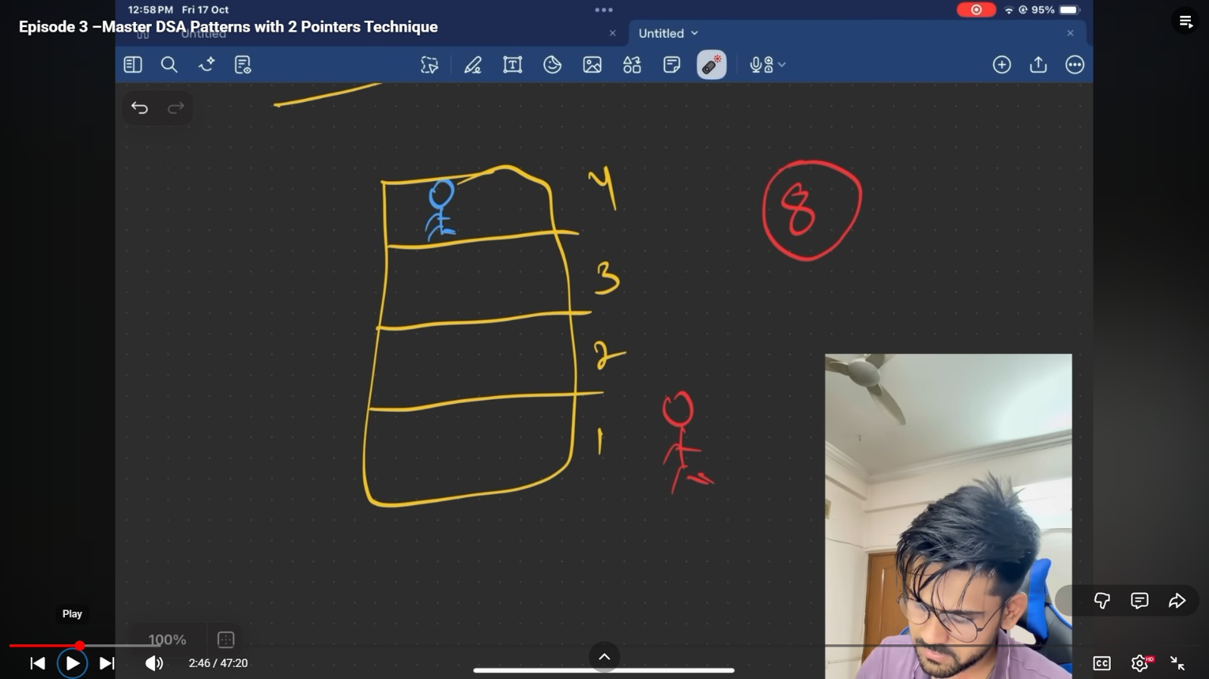

**How to know need to implement 2 pointers –**

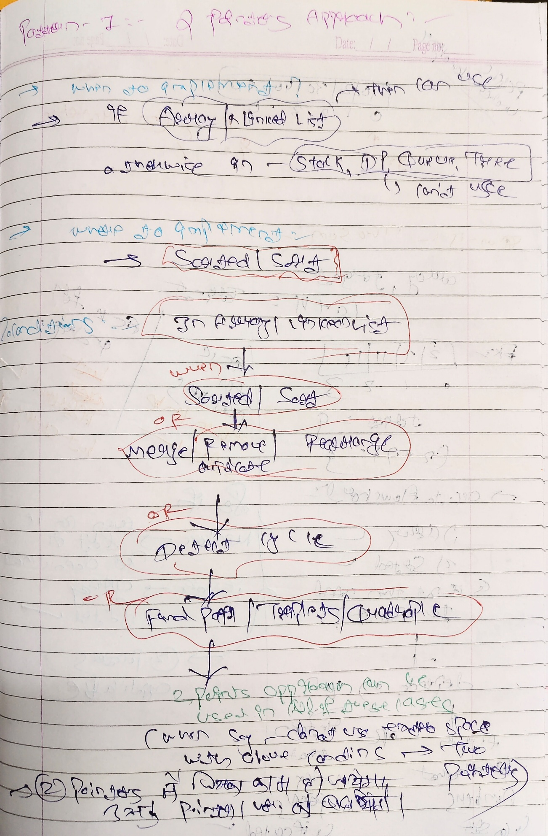

1. If qun is of ARRAY OR LL then can be used otherwise in other DS – Tree,Graph,stack,DP least or very less chances to apply

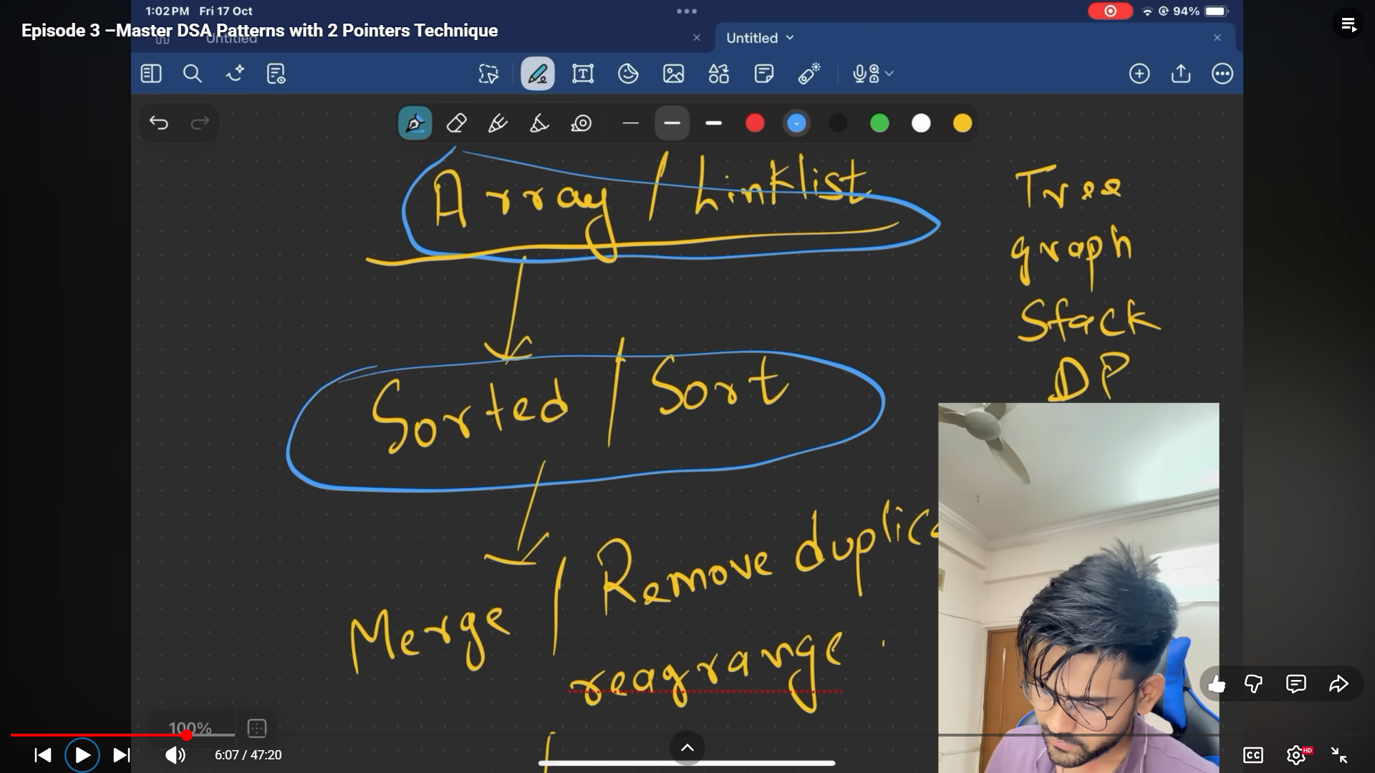

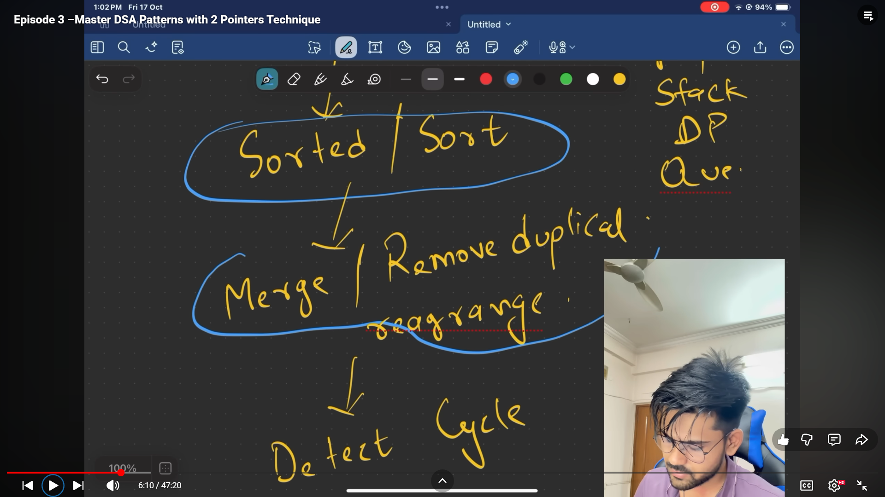

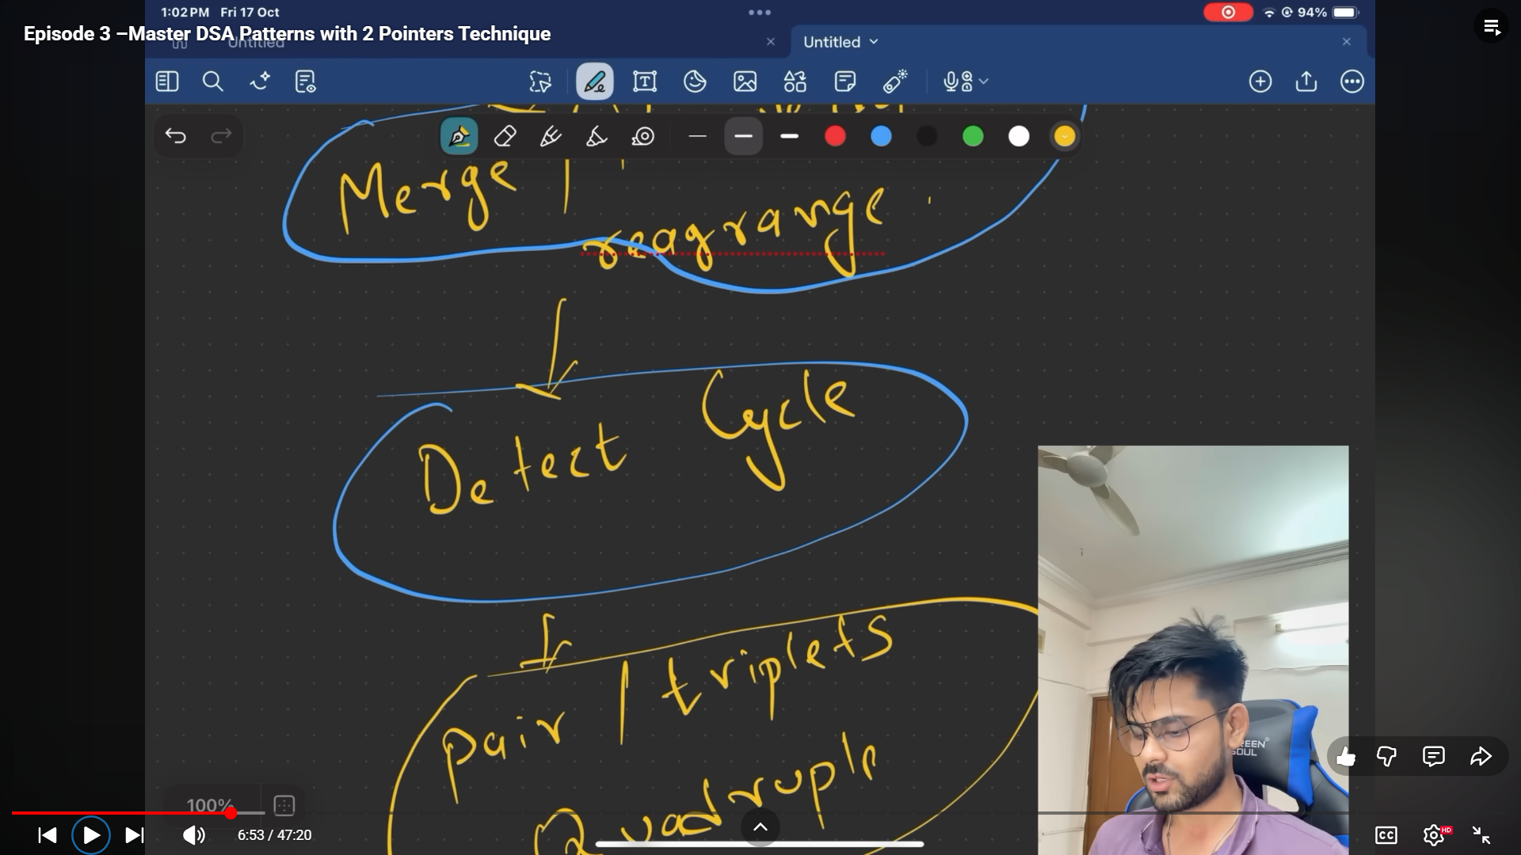

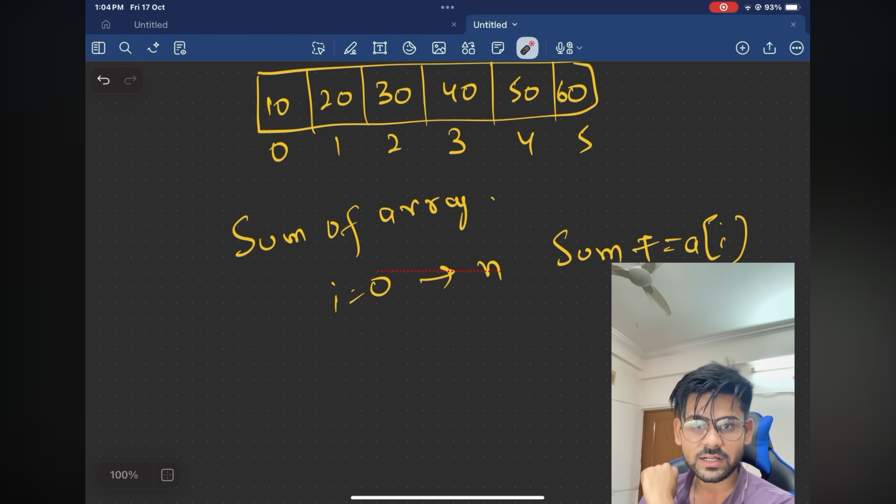

**Qun 1 – Two Sum -**

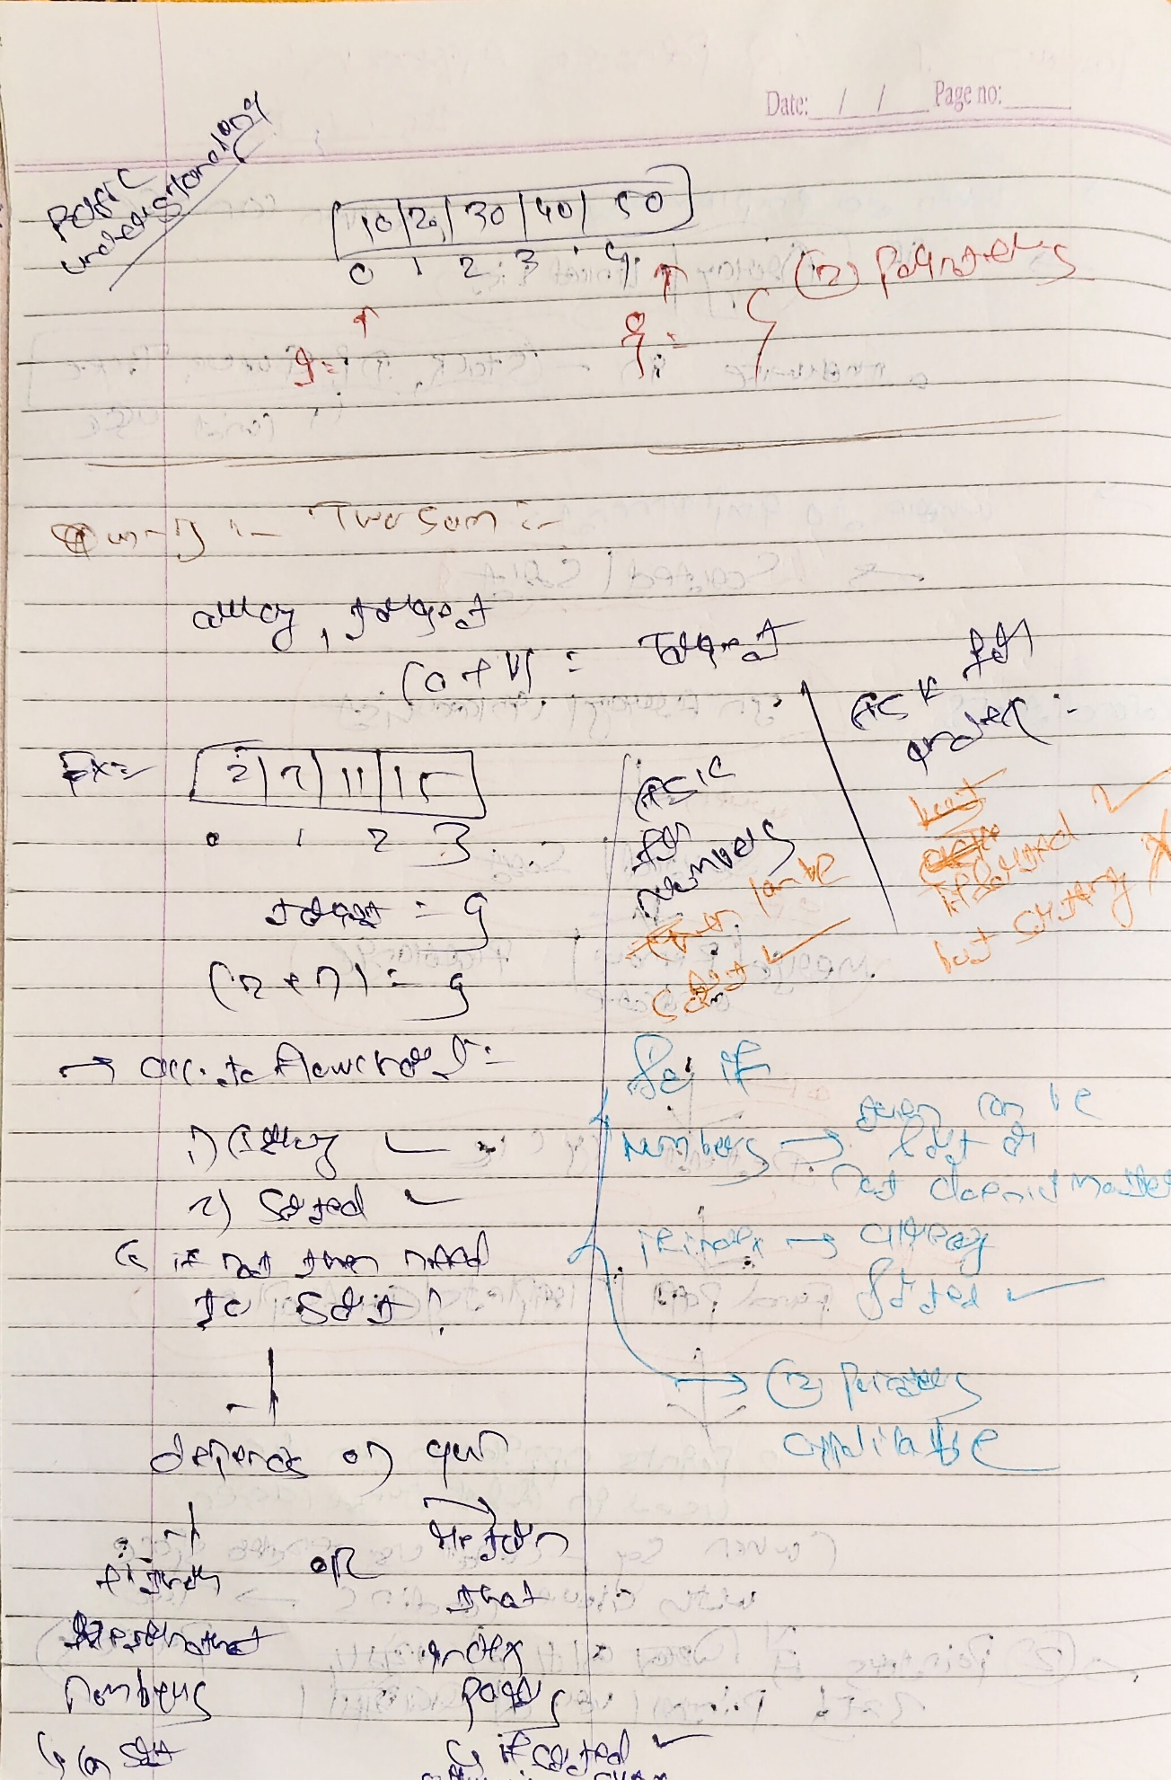

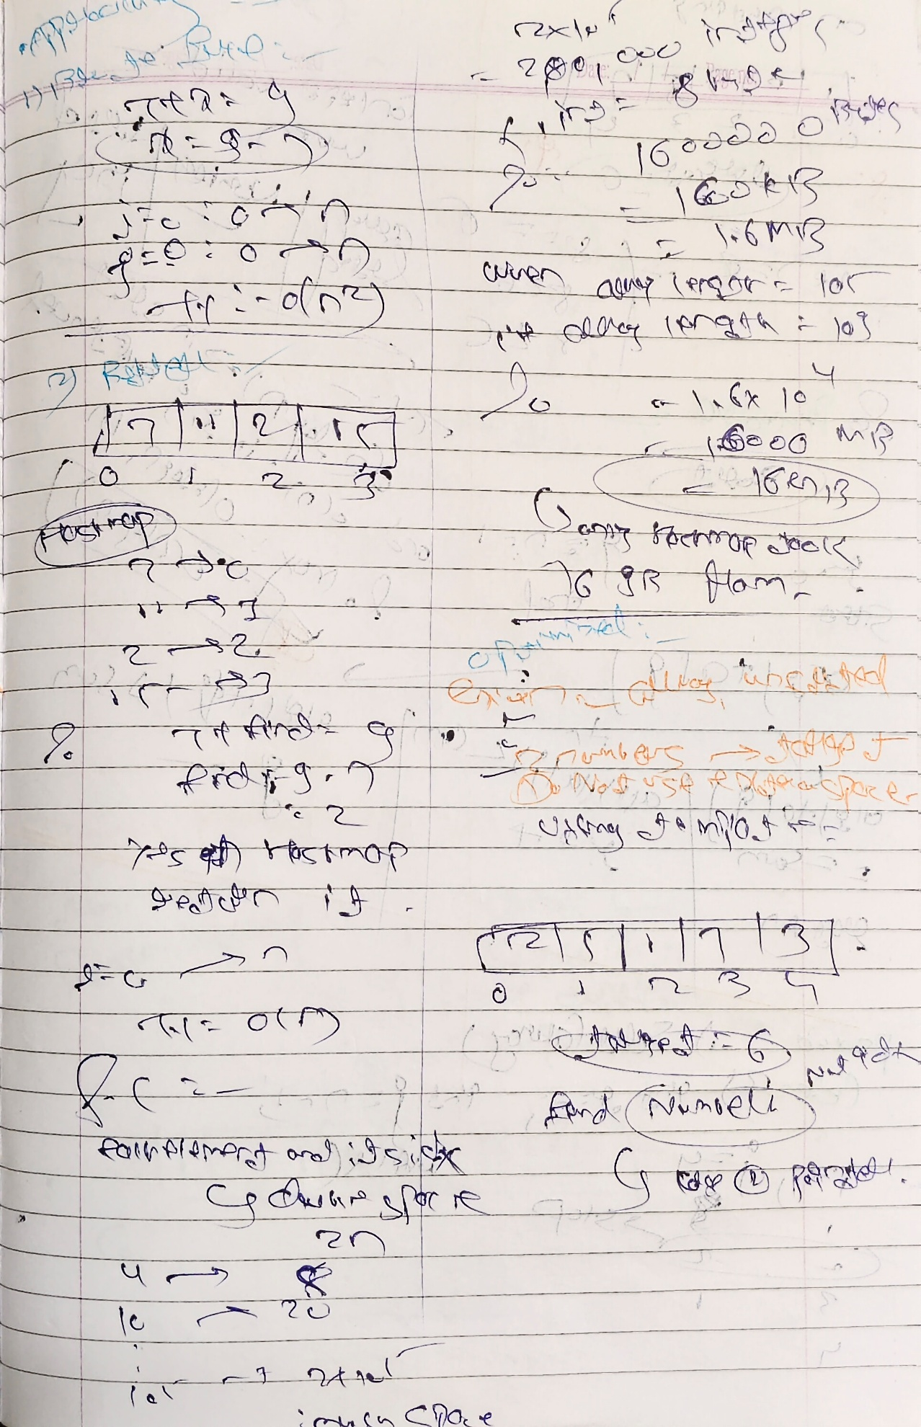

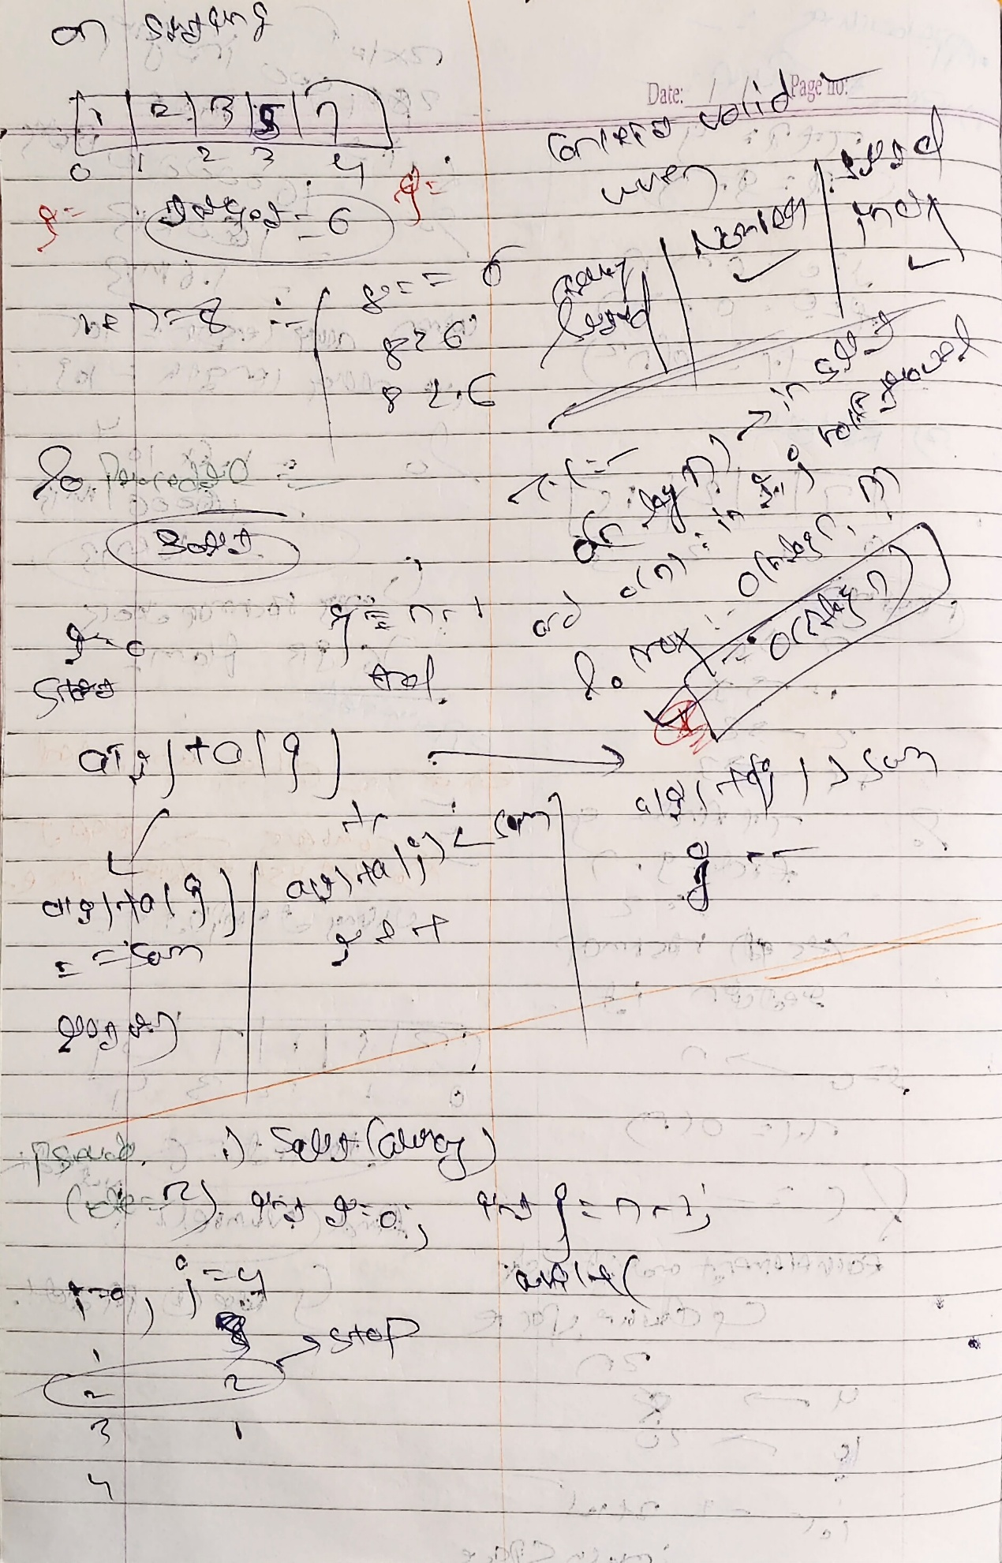

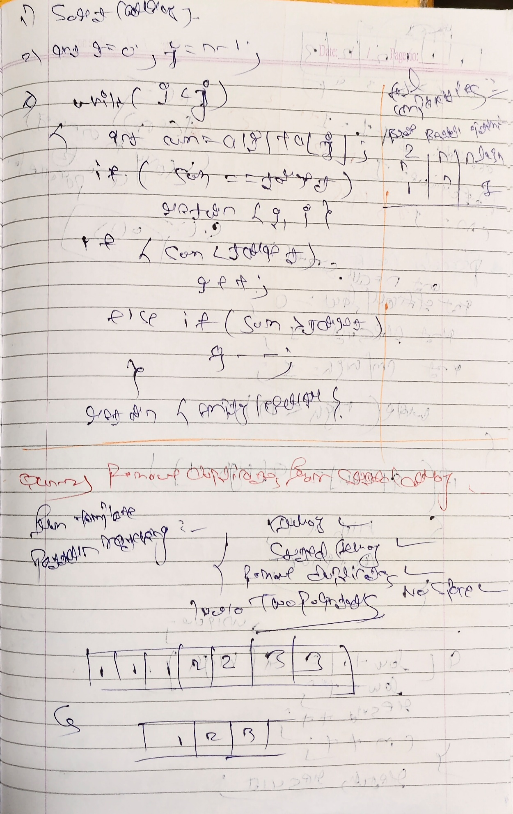

class Solution {

public:

    vector<int> twoSum(vector<int>& numbers, int target) {

        int i = 0, j = numbers.size() - 1;

        while (i < j) {

            int sum = numbers[i] + numbers[j];

            if (sum == target) {

                return {i + 1, j + 1};

            } else if (sum < target) {

                i++;

            } else {

                j--;

            }

        }

        return {};

    }

};

//_________________________________________

**Qun -2) Remove Duplicates (easy)**

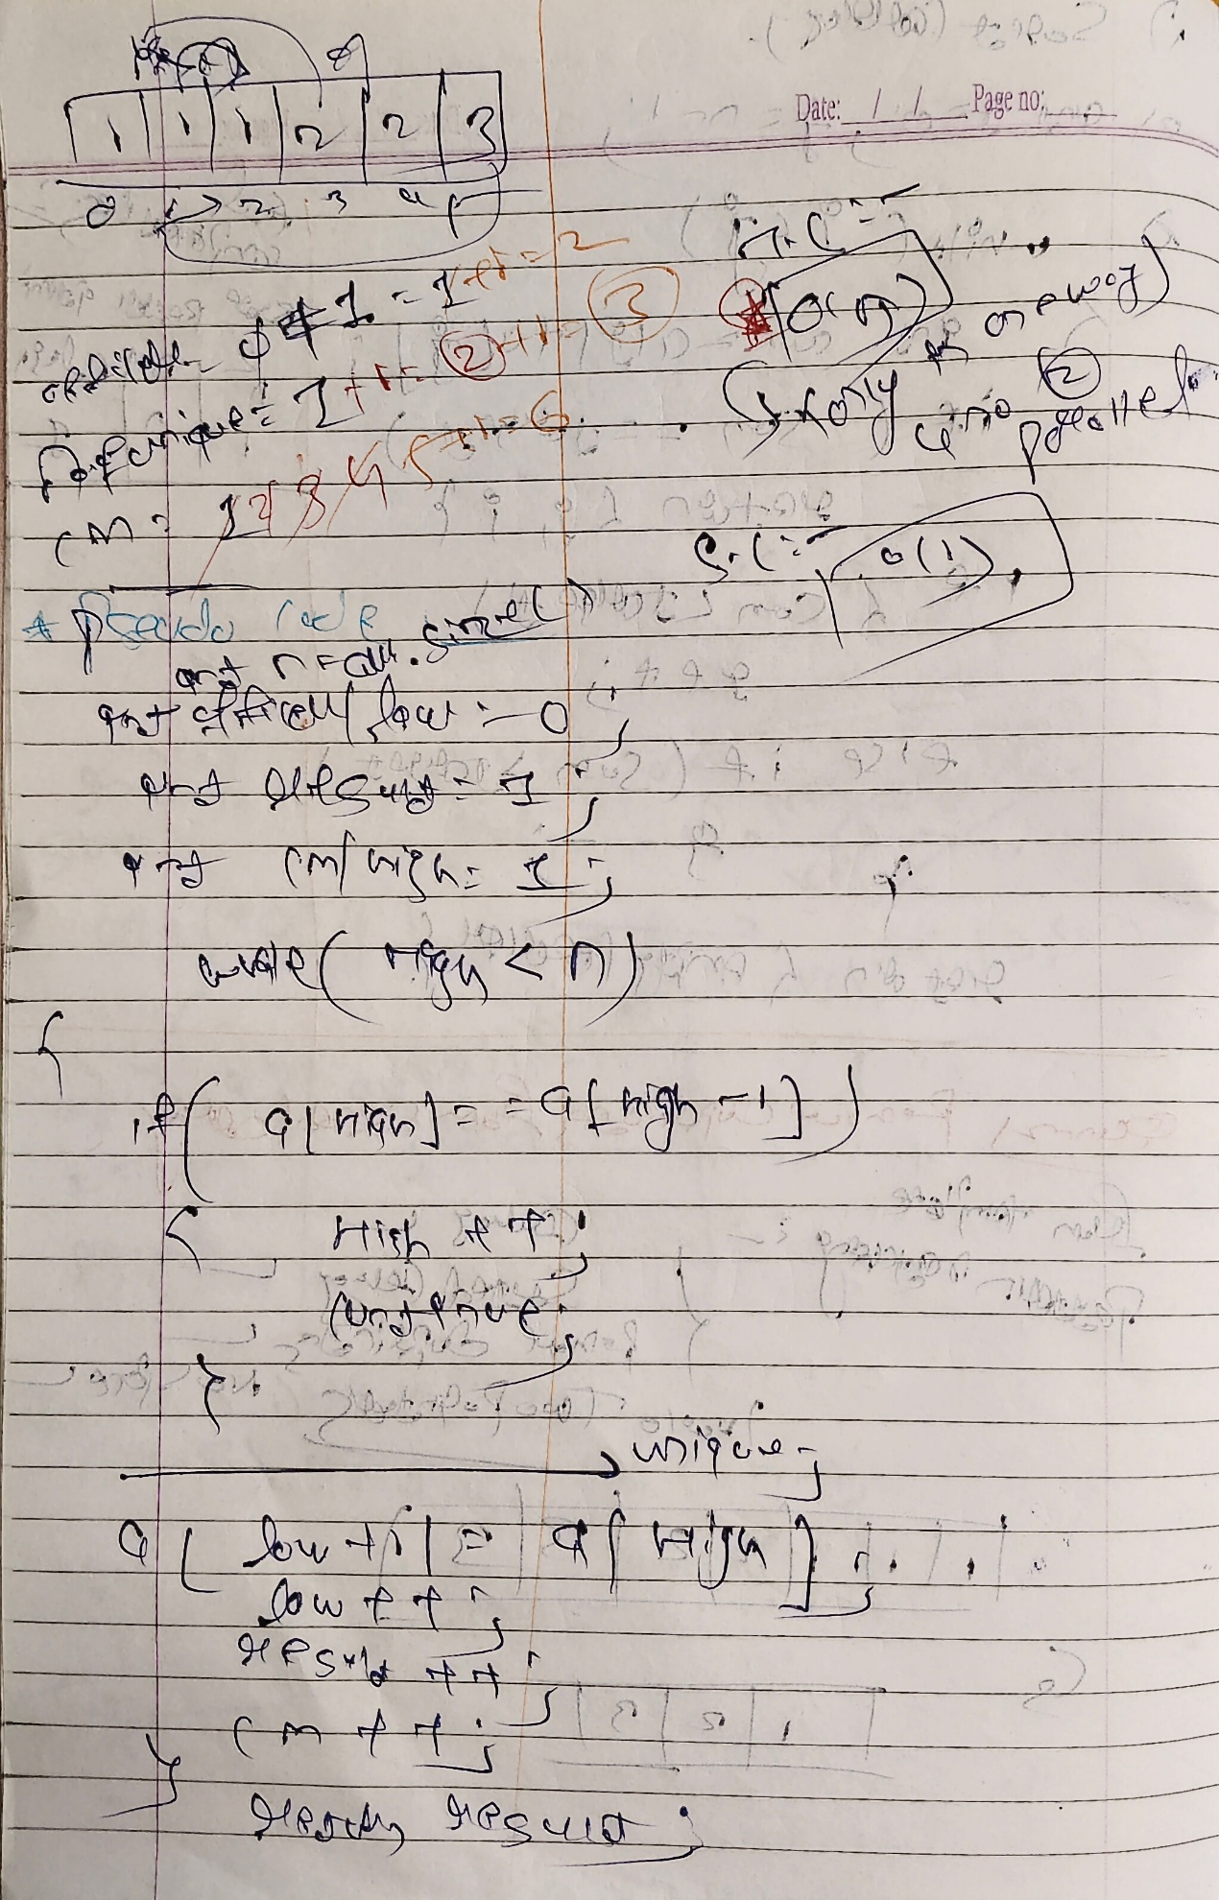

class Solution {

public:

    int removeDuplicates(vector<int>& nums) {

        int k = 1;

        for (int i = 1; i < nums.size(); i++) {

            if (nums[i] != nums[i - 1]) {

                nums[k] = nums[i];

                k++;

            }

        }

        return k;

    }

};

//_________________________________________

**Qun -3) Squaring a Sorted Array (easy)**

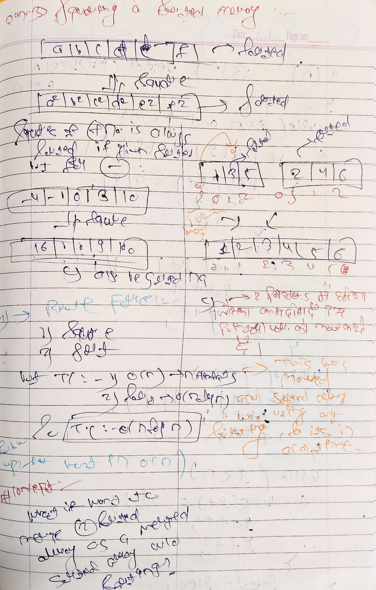

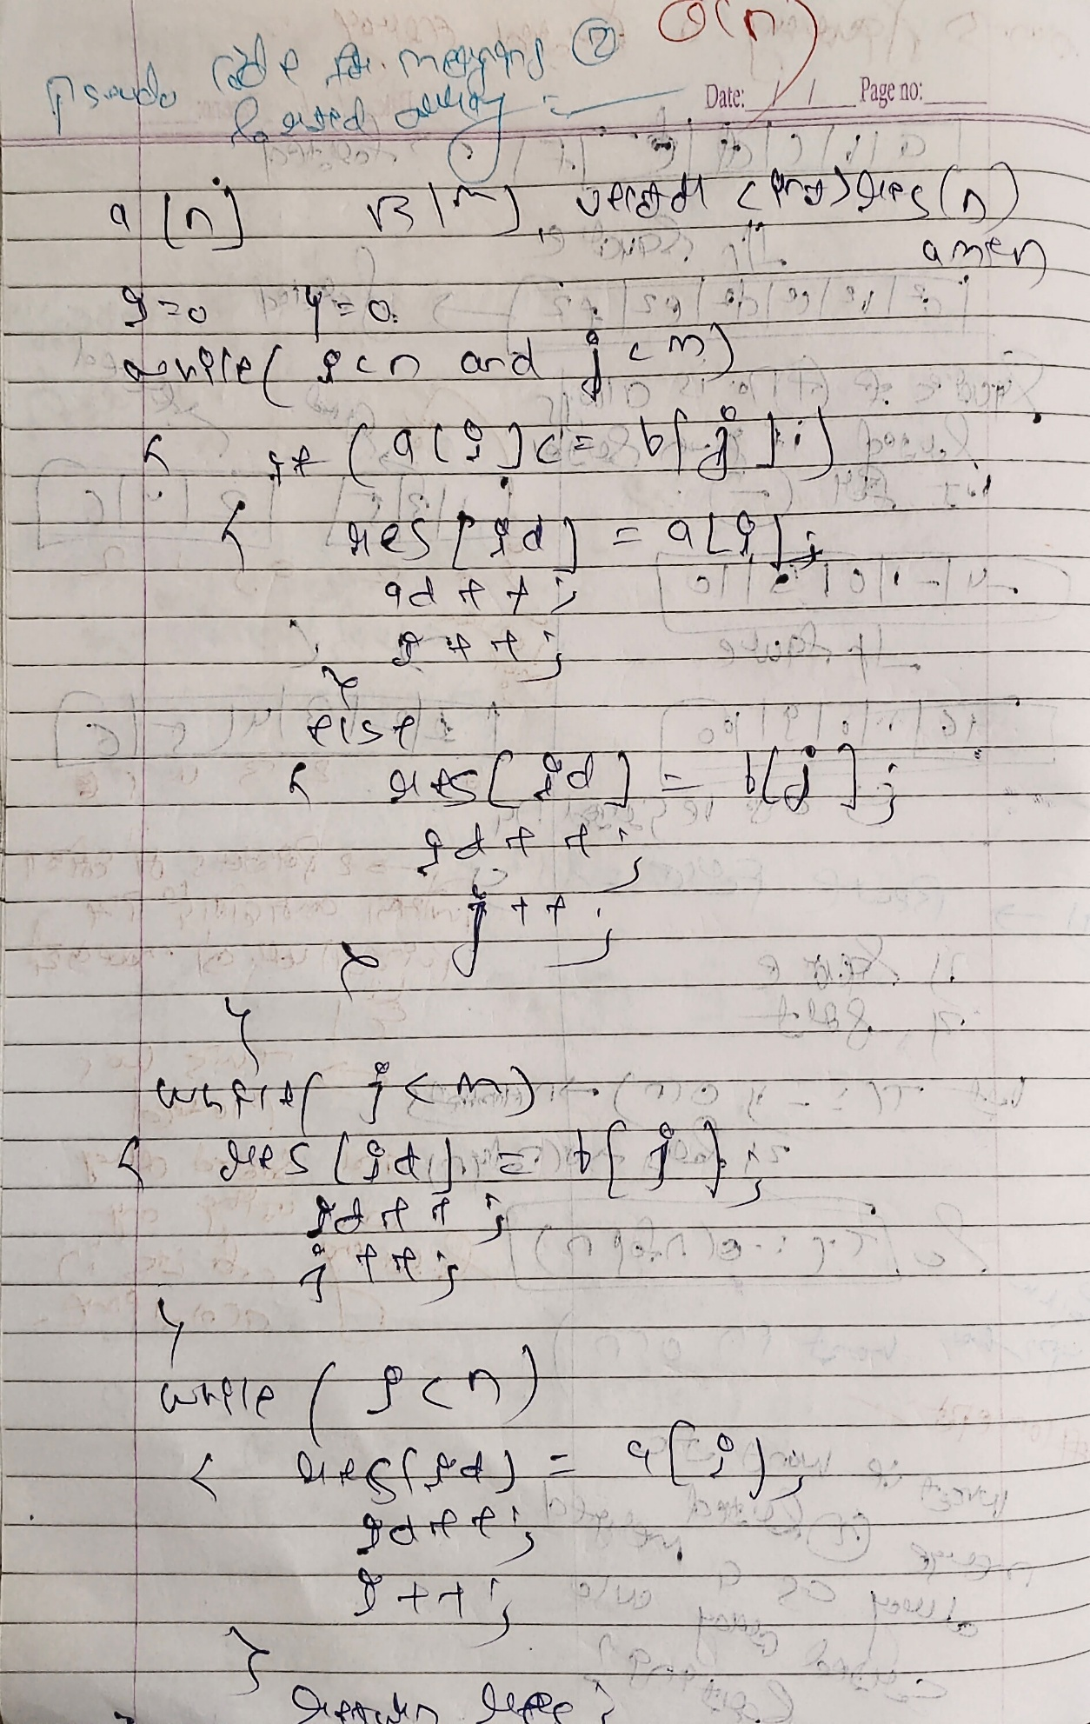

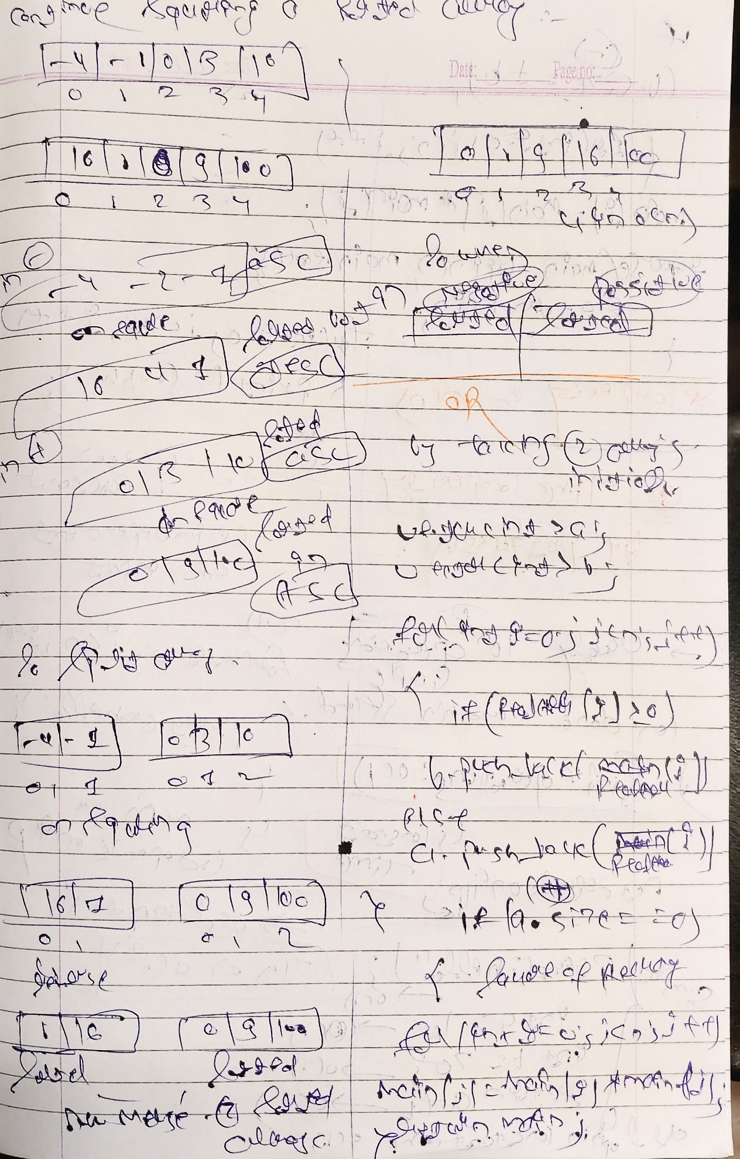

class Solution {

public:

ListNode* deleteDuplicates(ListNode* head) {

ListNode* curr = head;

while (curr && curr->next) {

if (curr->val == curr->next->val) {

curr->next = curr->next->next;

} else {

curr = curr->next;

}

}

return head;

}

};

//_________________________________________

**Time Complexity Concepts –**



